Muneeb ur Rehman
063 Section : C Lab Task 2
Software verification & validation

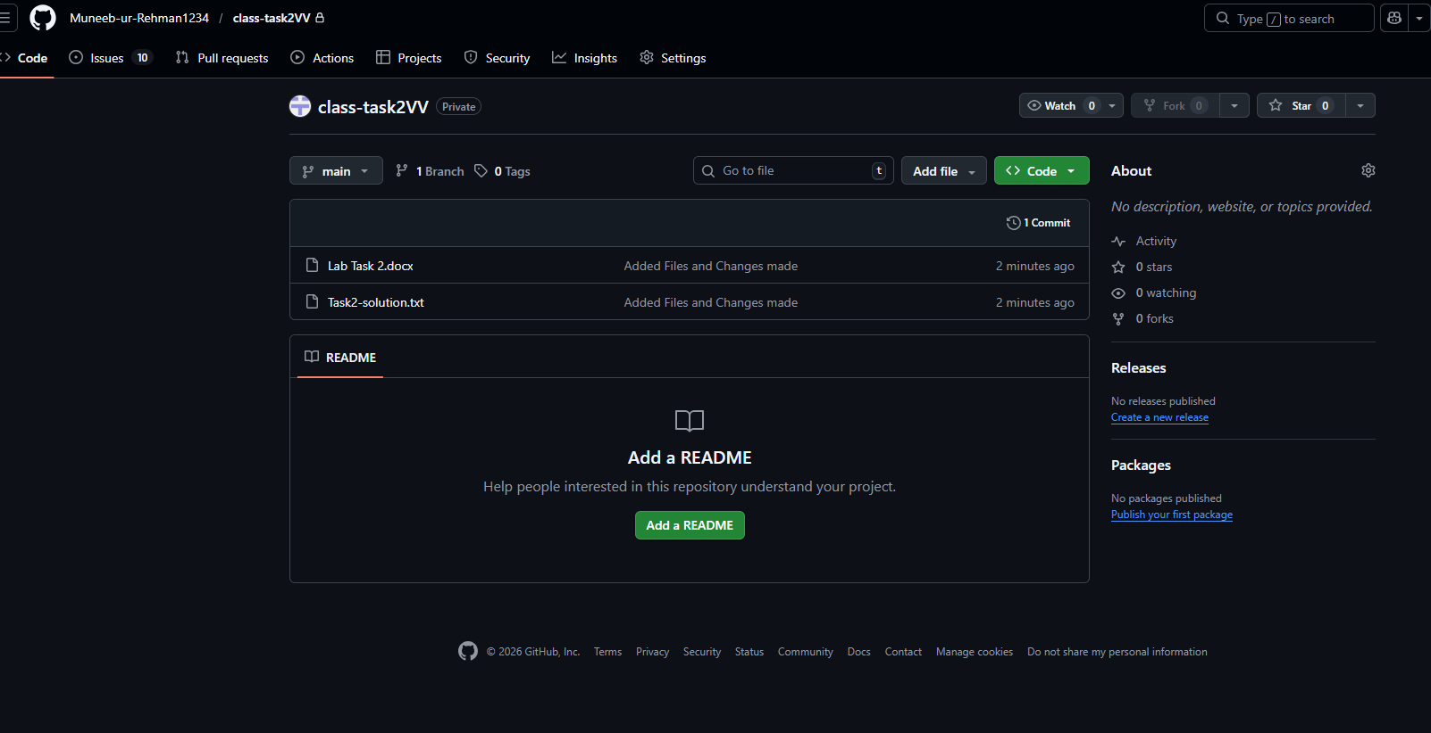

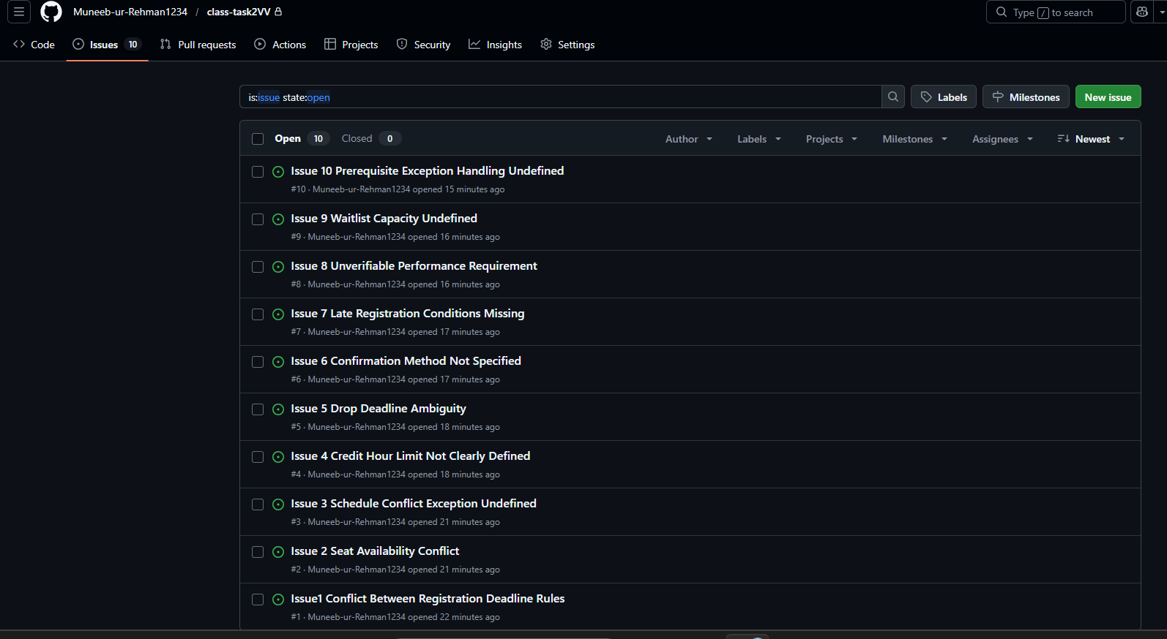

TASK A — DEFECT HUNT

The following defects were identified in the given requirement set. The defects are categorized into inconsistencies, incompleteness, ambiguities, unverifiable requirements, and missing business rules.

1. Inconsistencies (Logical Conflicts)
1.1 R2 vs R3

R2 states that the system shall not allow registration after the deadline.
R3 states that late registration is allowed for 3 days after the deadline.
These two requirements directly contradict each other.

1.2 R5 vs R16

R5 allows course registration even if seats are full.
R16 states that the system shall support waitlisting when seats are full.
If registration is allowed when seats are full, waitlisting becomes meaningless.

1.3 R9 vs R10

R9 states that the system shall prevent schedule conflicts.
R10 allows registration for two courses occurring at the same time if one is online.
R9 does not mention any exception, which creates a conflict.

1.4 R11 vs R12

R11 limits students to 18 credit hours per semester.
R12 allows up to 24 credit hours with advisor approval.
The maximum limit is unclear and not properly defined.

1.5 R13 vs R15

R13 allows students to drop courses until Week 6.
R15 states that the system shall not allow course drops after the deadline.
The term “deadline” is not clearly defined, causing conflict.

1.6 R7 vs R8

R7 prevents registration if prerequisites are not met.
R8 allows prerequisites to be ignored with instructor approval.
The exception handling process is not clearly defined.

2. Incompleteness (Missing Details)
2.1 R1

The type of students eligible for registration is not defined (e.g., active, suspended, alumni).

2.2 R4

The requirement does not specify whether seat availability is updated in real-time.

2.3 R6

The method and timing of sending confirmation are not specified.

2.4 R14

The drop fee amount or calculation method is not defined.

2.5 R16

The maximum capacity of the waitlist is not specified.

2.6 R19

The mechanism for providing priority enrollment to final-year students is not defined.

2.7 R3

The conditions for late registration approval are not defined.

3. Ambiguities
3.1 R20

The phrase “register quickly” is vague and lacks measurable criteria.

3.2 R6

The phrase “send confirmation” is unclear regarding timing and method.

3.3 R15

The term “deadline” is ambiguous and not clearly defined.

4. Unverifiable Requirements
4.1 R20

“Register quickly” cannot be measured or tested without a defined performance metric.

4.2 R6

Without specifying time and medium, confirmation delivery cannot be tested.

5. Missing Business Rules
5.1 Payment Rule Missing

There is no requirement specifying whether registration requires payment confirmation.

5.2 Duplicate Registration Rule Missing

There is no requirement preventing students from registering for the same course multiple times.

TASK B — DEFECT LOGGING (GitHub Issues Format)

The following defects are logged as GitHub issues.

Issue 1

Title: Conflict Between Registration Deadline Rules
Requirement ID: R2 & R3
Defect Type: Inconsistency
Description: R2 prohibits registration after the deadline while R3 allows late registration for 3 days.
Impact: Developers cannot implement consistent registration logic.
Suggested Fix: Define late registration as an exception with approval conditions.
Priority: High

Issue 2

Title: Seat Availability Conflict
Requirement ID: R5 & R16
Defect Type: Inconsistency
Description: R5 allows registration when seats are full while R16 introduces waitlisting.
Impact: Contradictory enrollment logic.
Suggested Fix: Prevent direct enrollment when full and allow waitlisting only.
Priority: High

Issue 3

Title: Schedule Conflict Exception Undefined
Requirement ID: R9 & R10
Defect Type: Inconsistency
Description: R9 blocks schedule conflicts but R10 introduces an exception without clarification.
Impact: Implementation confusion.
Suggested Fix: Modify R9 to include exception for online asynchronous courses.
Priority: High

Issue 4

Title: Credit Hour Limit Not Clearly Defined
Requirement ID: R11 & R12
Defect Type: Inconsistency
Description: Maximum credit hours unclear (18 or 24).
Impact: Academic policy confusion.
Suggested Fix: Define 18 as default and 24 with advisor approval.
Priority: High

Issue 5

Title: Drop Deadline Ambiguity
Requirement ID: R13 & R15
Defect Type: Ambiguity
Description: The drop deadline is not clearly defined.
Impact: Potential disputes regarding eligibility.
Suggested Fix: Specify exact week or calendar date.
Priority: Medium

Issue 6

Title: Confirmation Method Not Specified
Requirement ID: R6
Defect Type: Incomplete
Description: Mode and timing of confirmation not mentioned.
Impact: Notification feature cannot be properly implemented.
Suggested Fix: Specify email and dashboard notification within defined time.
Priority: Medium

Issue 7

Title: Late Registration Conditions Missing
Requirement ID: R3
Defect Type: Incomplete
Description: Approval process for late registration not defined.
Impact: Business process ambiguity.
Suggested Fix: Require advisor approval through system workflow.
Priority: High

Issue 8

Title: Unverifiable Performance Requirement
Requirement ID: R20
Defect Type: Unverifiable
Description: “Register quickly” is not measurable.
Impact: Cannot test system performance.
Suggested Fix: Define measurable time constraint.
Priority: Medium

Issue 9

Title: Waitlist Capacity Undefined
Requirement ID: R16
Defect Type: Incomplete
Description: Waitlist size not specified.
Impact: Potential system capacity issues.
Suggested Fix: Define maximum waitlist size.
Priority: Medium

Issue 10

Title: Prerequisite Exception Handling Undefined
Requirement ID: R7 & R8
Defect Type: Inconsistency
Description: Instructor approval process not defined.
Impact: Access control ambiguity.
Suggested Fix: Define digital approval mechanism within system.
Priority: High

TASK C — REWRITTEN CORRECT REQUIREMENTS

The following requirements are rewritten to be clear, testable, complete, and non-conflicting.

Revised R1

The system shall allow active enrolled students to register for available courses during the official registration period.

Revised R2 & R3

The system shall allow course registration until the official registration deadline. Late registration shall be permitted for up to 3 calendar days after the deadline with advisor approval recorded in the system.

Revised R4

The system shall display real-time available seat counts for each course section.

Revised R5 & R16

If a course section is full, the system shall prevent direct enrollment and shall allow students to join a waitlist.

Revised R6

The system shall send an email and dashboard confirmation within one minute after successful course registration.

Revised R7 & R8

The system shall prevent registration if prerequisites are not met unless an instructor provides digital approval within the system.

Revised R9 & R10

The system shall prevent students from registering for courses with schedule conflicts, except when one of the courses is fully online and asynchronous.

Revised R11 & R12

The system shall limit students to a maximum of 18 credit hours per semester. Students may register for up to 24 credit hours only after advisor approval is recorded in the system.

Revised R13, R14 & R15

Students may drop courses until the end of Week 6 of the semester. A drop fee shall be charged for drops made after Week 2. Course drops shall not be permitted after Week 6.

Revised R20

The system shall complete the course registration transaction within three seconds under normal operating conditions.

